The Arlington Food Assistance Center (AFAC)
provides 2,400 Arlington families and individuals with dignified access to nutritious, supplemental groceries,
free of charge.

Headed to the store to stock up? Please help AFAC support families during this critical time by donating canned and shelf-stable food items.

  - The most needed foods are:
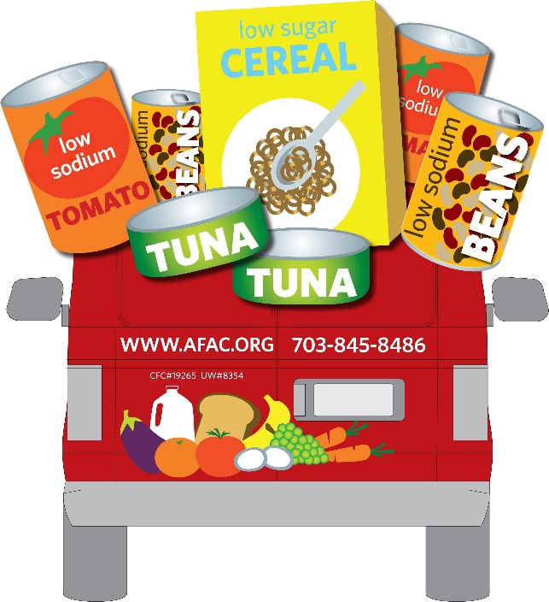
- *Low sodium & low sugar preferred.
- *No glass please!
  - Canned Tuna & Chicken
  - Canned Soups
  - Canned Vegetables
  - Canned Tomatoes
  - Peanut Butter (in plastic jars)
  - Pasta
  - Rice
Thank you so much for your support!
Learn more at www.afac.org

