The Arlington Food Assistance Center needs your help to feed 2,300 families every week.

Help “YOUR ORGANIZATION” feed our
Arlington neighbors in need.

Bring in your food donations to
“LOCATION” until “END DATE.”

The items we need most are:
- *Low sodium preferred
- *Low sugar preferred
- *No glass

- Canned tuna
- Canned soup
- Canned vegetables
- Peanut butter
- Cereal

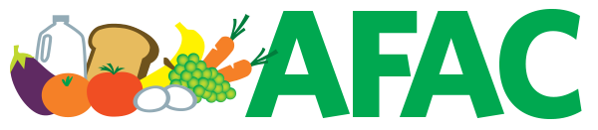
Thank you so much for your support!
Learn more at www.afac.org

