The Arlington Food Assistance Center
needs your help to collect 100,000 pounds
of heart-healthy foods this month.
Help “YOUR ORGANIZATION” feed our
Arlington neighbors in need.

Bring in your food donations to
“LOCATION” until “END DATE.”
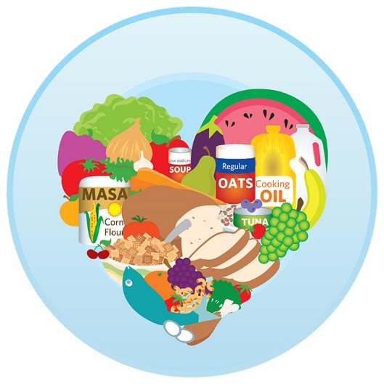
Look for labels that say:
low sodium, no salt added,
no sugar added, or unsweetened.
  - Canned Tuna
  - Canned Soups
  - Canned Vegetables
  - Peanut Butter (in plastic jars)
  - Low Sugar & High Fiber Cereal
*No glass

Thank you so much for your support!
Learn more at www.afac.org

