The Arlington Food Assistance Center (AFAC)
provides 2,300 Arlington families and individuals with dignified access to nutritious, supplemental groceries,
free of charge.

The best food donations are healthy
(low-fat, low-sugar, low-sodium) and meet the needs
of the multicultural communities served by AFAC.
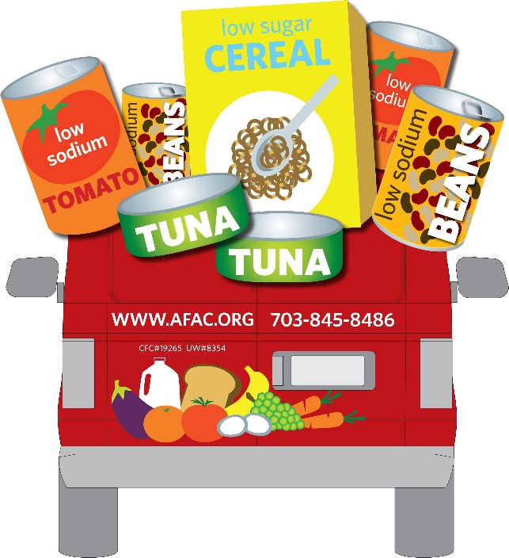
  - The foods needed most are:
- *Low sodium & low sugar preferred.
- *No glass please!
  - Canned Tuna
  - Canned Soups
  - Canned Vegetables
  - Peanut Butter (in plastic jars)
  - Low Sugar Cereal

Thank you so much for your support!
Learn more at www.afac.org

