Arlington Food Assistance Center (AFAC)
needs your help to collect 100,000
pounds of food this month!
Help “YOUR ORGANIZATION” feed our Arlington
neighbors in need. Bring in your food donations to
“LOCATION” until “END DATE”.

The items we need most are:
- *Low sodium & low sugar preferred.
- *No glass please!

- Canned tomato products (diced, tomato, and sauce)
- Canned soup
- Canned fruit
- Peanut butter
- Pasta
- Low Sugar Cereal

Thank you so much for your support!
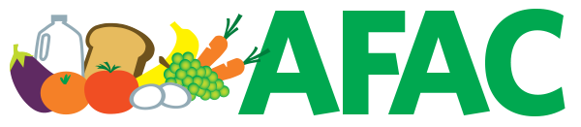
Learn more at www.afac.org
Text to give! Send message:
<AFAC> <donation amount> <your name> to 41444

