Arlington Food Assistance Center (AFAC)
needs your help to collect 100,000 pounds
of Heart Healthy foods this month!
Help “YOUR ORGANIZATION” feed our
Arlington neighbors in need.

Bring in your food donations to
“LOCATIONS” until “END DATE”.
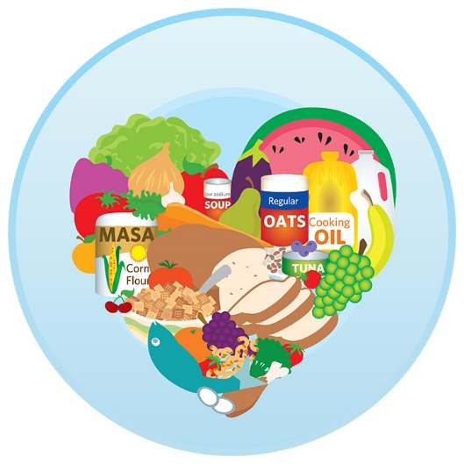
  - The items we need most are
low in sodium and high in fiber:
*No glass please!
  - Canned Tomato
(diced, tomato, and sauce)
  - Canned Soups
  - Canned Fruit
  - Peanut Butter (in plastic jars)
  - Pasta
  - Low Sugar Cereal

Thank you so much for your support! Learn more at www.afac.org
Text to give! Send message: <AFAC> <donation amount> <your name> to 41444

