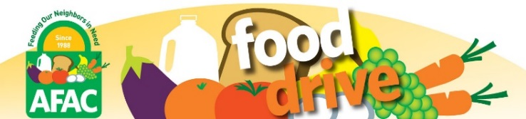
Help “GROCERY STORE” and the
Arlington Food Assistance Center
Drive Away Hunger!
“DATE”
“TIME”
You can feed your neighbors in need by donating:
- low sodium & low sugar canned:
soups, tomato products, fruit
- peanut butter (in plastic jars)
- low sugar cereal
- pasta
Thank you for your support! Learn more: www.afac.org
Help us RECYCLE: please return this flyer to AFAC volunteers.
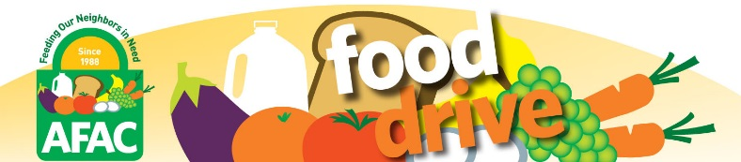
Help “GROCERY STORE” and the
Arlington Food Assistance Center
Drive Away Hunger!
“DATE”
“TIME”
You can feed your neighbors in need by donating:
- low sodium & low sugar canned:
soups, tomato products, fruit
- peanut butter (in plastic jars)
- low sugar cereal
- pasta

Thank you for your support! Learn more at www.afac.org
Help us RECYCLE: please return this flyer to AFAC volunteers.
Help “GROCERY STORE” and the
Arlington Food Assistance Center
Drive Away Hunger!
“DATE”
“TIME”
You can feed your neighbors in need by donating:
- low sodium & low sugar canned:
soups, tomato products, fruit
- peanut butter (in plastic jars)
- low sugar cereal
- pasta

Thank you for your support! Learn more at www.afac.org
Help us RECYCLE: please return this flyer to AFAC volunteers.

Help “GROCERY STORE” and the
Arlington Food Assistance Center
Drive Away Hunger!
“DATE”
“TIME”
You can feed your neighbors in need by donating:
- low sodium & low sugar canned:
soups, tomato products, fruit
- peanut butter (in plastic jars)
- low sugar cereal
- pasta

Thank you for your support! Learn more at www.afac.org
Help us RECYCLE: please return this flyer to AFAC volunteers.

