The Arlington Food Assistance Center (AFAC)
provides 2,200 Arlington families and individuals dignified access to nutritious, supplemental groceries — free of charge.

The best food donations are healthy (low-fat, low-sugar, low-sodium), but also meet the needs of the multicultural communities — Bolivians, Ethiopians, Russians, and more —
that come to AFAC for supplemental groceries.
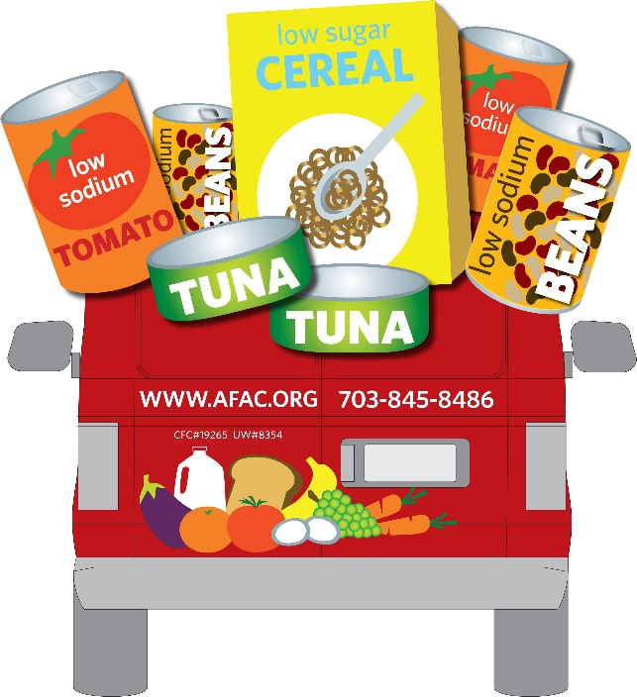
  - THE ITEMS WE NEED MOST ARE:
- *Low sodium & low sugar preferred.
- *No glass please!
  - Canned Tomato
(diced, tomato, and sauce)
  - Canned Soups
  - Canned Fruit
  - Peanut Butter (in plastic jars)
  - Pasta
  - Low Sugar Cereal

Thank you so much for your support! Learn more at www.afac.org
Text to give! Send message: <AFAC> <donation amount> <your name> to 41444

